EECS 739
Directions for Submitting Parallel Jobs to SLURM Cluster at ITTC:

1. This only applies to students who wish to log onto ITTC machines from OFF CAMPUS. (Please skip Step 1 when connecting to ITTC machines from ON CAMPUS.)
For graduate students logging into ITTC machines from OFF CAMPUS, you must first connect via the VPN. See the figures below.
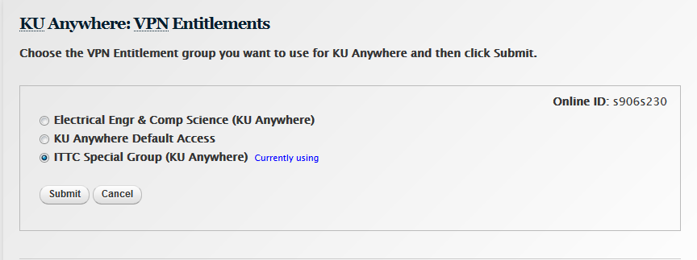
Note: This screenshot is out-of-date. The use of VPN now requires the use of Duo Mobile.

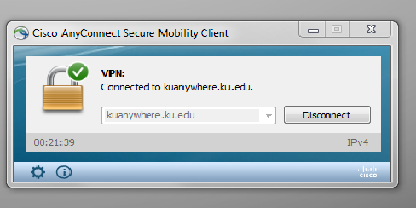
Due to KU policy, undergrads are NOT given access to VPN. When connecting to ITTC machines from OFF CAMPUS, you must first login to the EECS cycle servers. If you need help with this, please see me.
2. FTP files to login1.ittc.ku.edu. [When connecting from ON CAMPUS, start here.]
If you need help with this, please see me. (The directions are different depending on whether you are FTPing files from a linux machine or a Windows machine.)

3. SSH to login1.ittc.ku.edu. (The figure below shows how to do this from a Windows machine.)
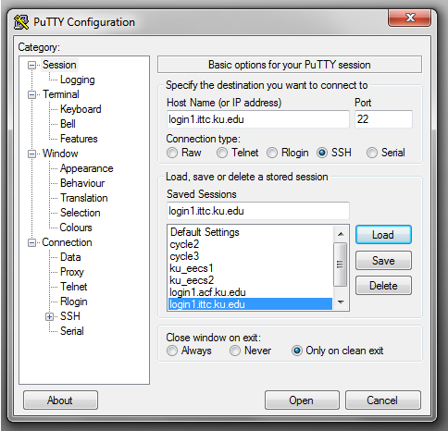

4. (You are on the login1 node now.) srun -p intel -c 4 –mem 4G –pty /bin/bash
5. (On a compute node such as n097 now.) n097: module load OpenMPI
6. n097: Change to the directory with your code. Use the cd command.
7. n097: Compile your MPI and C/C++ code: mpic++ -o mpi_send_recv_1 mpi_send_recv1.c
8. n097: Submit your job to the queue: sbatch shontz-parallel.sbatch

